MACHINERY BEST PRACTICE FOR TEG PUMPS

RAMKUMAR THIRAVIAM & NIRAV DOSHI

Abstract:
In Oil & Gas industry, before treated gas is exported or supplied to end user, impurity such as water vapor must be removed which helps to prevent hydrate formation and to prevent corrosion in downstream system. The Glycol Dehydration Unit system (GDU System) used for this application includes glycol re-circulation pump which is used to circulate glycol in the glycol contactor. The glycol circulation pump typically operates with low flow and high head. Many package suppliers use reciprocating pump for this application due lower at CAPEX. As compared to rotary pumps, reciprocating pump may have higher OPEX due to high wear and tear and are also prone to pulsation related issues. The accumulator used to dampen pulsation are also prone to failures, if it not selected correctly. Due to low operating speeds, the system may be prone to base frame related resonant excitations.
This article aims to discuss the plausible options for the glycol re-circulation pump selection (Centrifugal/Rotary). This article explores the possibilities and benefits to use centrifugal/rotary pump and gives brief insight about the necessary precautions to be taken care to avoid above mentioned issues for reciprocating pumps when selected
Key Words: Glycol pump, dehydration package, reciprocating pump, screw pump, pulsation
Introduction
Natural gas is normally fully saturated with water vapor when extracted from an underground reservoir. Water vapor in Natural Gas form hydrates in gas pipelines which has a significant impact to machinery and pipe systems leading to unplanned production shutdowns. Since most of the water vapor must be removed from natural gas before it can be treated further for various uses, all natural gas is subjected to a dehydration process. One of the most common methods for removing the water from produced gas is by a glycol dehydration unit
Glycol dehydration itself is a process unit with various types of equipment and most consultants and EPC contractors consider it as a black box. They prefer to leave the scope of detailing inside the unit to the packager and often it is expected to be built in a structural module, ready to install at site with minimum assembly work. With changing world and possibilities to transport large modules from one part to other part of world, even large glycol dehydration units are being built in modules. As the capacity of the dehydration unit increases the duties of glycol circulation is also getting bigger. It is now common to find reciprocating pumps more than 100 kW being used for glycol dehydration and sometimes installed inside the structural module of glycol dehydration package.
The circulation of lean glycol is usually done with a pump. The required circulation rate in dehydration units are comparatively small with high differential pressure (due to contractor high pressure). The glycol circulation rate is determined based on several parameters such as water content in the gas, glycol purity and the glycol contactor design. However, the pump is selected for the circulation capacity only that is minimum necessary to remove the required water from gas, as any over-circulation just adds inefficiency to the system. Therefore, a plunger type Reciprocating pump is normally employed for this service.
Refer below figure/sketch for visualization of glycol dehydration package.
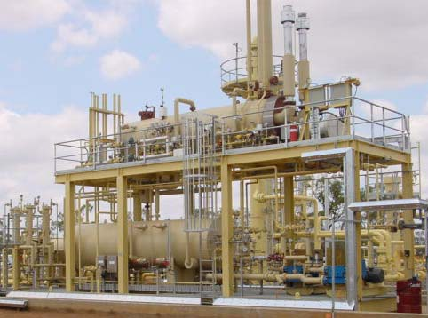
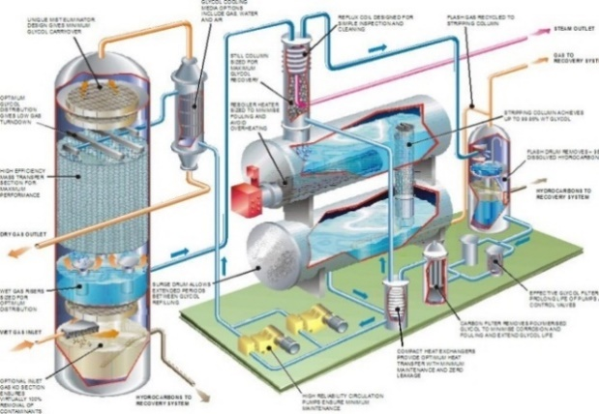
Figure 1, Top- A typical view of TEG dehydration package and Bottom - process sketch.
In most cases, this circulation pumps are installed on module, dynamic forces generated by reciprocating pumps cause the structure to vibrate. This vibration leads to piping failures, poor equipment reliability, and safety concerns.
Since the dehydration system requires a minimum flow to be ensured for glycol contactor for design gas flow always, pump selection results in a simple reciprocating pump, where flowrate is a function of pump speed and not dependent on the pump head or system resistance. Refer below figure for typical reciprocating pump skid.
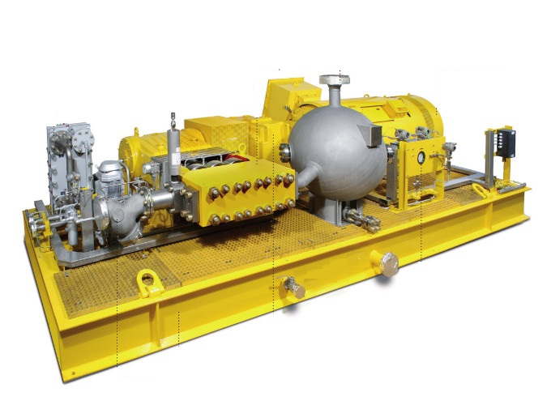
Bladderless Dampener
Gas Filled Dampener
Fig. 2, Typical skid arrangement for reciprocating pump.
While using the reciprocating pump, we should consider following key advantages and disadvantages of glycol Circulation application:
Benefits of using reciprocating pump
- High efficiency
- Commonly available for the required low flow - high pressure combination,
- Continuous rate of discharge capacity
- Low Capital Cost and smaller foot print
Problems of using reciprocating pump
- Pulsating flow and pressure (careful design of Piping system is essential)
- High wear in parts
- Pulsation dampener bladder becomes a weak point in design
- High maintenance cost
- Low Reliability
- More parts, meaning more spare parts inventory
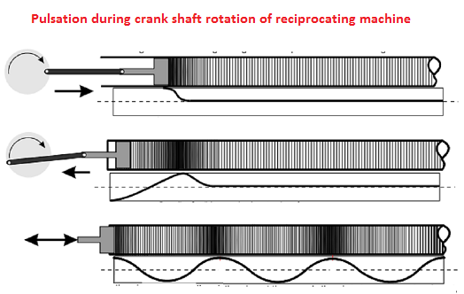
Fig. 3, Pulsation during crank shaft rotation for reciprocating pump.

Pressure pulsations produced by these pumps are a source of noise and vibration and may have a significant influence on the reliability of a given installation. Having known the advantages and disadvantages of reciprocating pumps, following key aspects to be focused when using a reciprocating type pump for glycol dehydration package:
As the base frames have first two resonant frequencies hence resonant excitation during a reciprocating machine operation is quite incipient. The below time wave form shows the vibration at very low order which can easily be proximity to base frame structural resonance. At resonance, the forces are amplified up to 20 times as there is no damping between two metallic connections (pump and base frame), and cause structural and associated components to vibrate much above safe operating limit. This issue become more aggravated where grout-less design is opted when pump is installed on metallic skid of glycol dehydration unit.
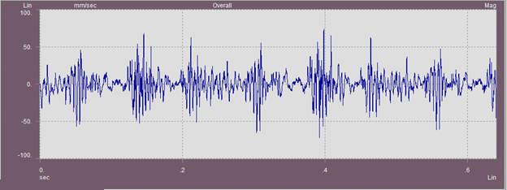
Fig 4.a, Time wave form of axial vibration during pump operation

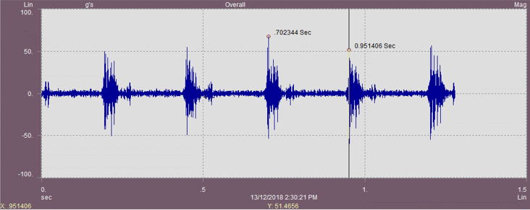
Fig 4.b, Time wave form of high impact during pump operation

Bigger the pumps, higher is the pulsation induced unbalance forces and it is essential to provide rigid foundation to avoid pulsation resonance. Installing medium to large reciprocating machines on the structural module requires special care during designing the module structure and requires dynamic analysis to properly address the vibrational behavior. This is especially true in offshore installations where the foundation is flexible.
At engineering stage, once model is completed along with piping, selection of dampener and recirculation pump selection, complete piping layout along with dampener and pump details are taken in to pulsation study either by packager or third party, based on outcome of the study, recommendations are implemented in the system. Brief notes are provided for reader in forthcoming paragraphs to understand the complexities and details of analysis and design of components when reciprocating type pumps are chosen for service.
Pulsation analysis means the examination of piping system for resonance and harmonics of the frequency at which the reciprocating pump, discharge the liquid in to the piping system. Whilst mechanical response means the examination of the piping system for its modal or frequency response, sometimes referred to as natural frequency and higher order modes of vibration. The mechanical response analysis is not just a dry simulation of a hammer or knock test to find the natural frequency of piping system but rather it is full simulation including fluids in the piping, temperature effect and most importantly dynamics forces from the pulsation simulation. Historically, such analysis work had done using hand calculation methods, empirical formulas, nomogram charts as well as experience to establish the piping frequency of the pump and then determine the natural frequency of piping spans where piping spans were found to have a low natural frequency then supports would be added, moved, or deleted to achieve a suitable natural frequency of the system. In addition to this similar technique were used to examine the suction and discharge pressure to ensure that problems with acceleration head in the suction line or excessive pulsation in the discharge line do not cause problem either with the operation of the pump or the operation of any PRVs on the line.
Today, whilst the task remains the same the advent of powerful computers and user friendly software for both pressure pulsations within the pumped liquid, and mechanical analysis of structures has enabled grater details modeling usually 3D of piping structures and transfer analysis.
Not all pulsation study outcome required to have modification or installation of pulsation dampeners however where such devices required to installed with grater care such devices shall be selected.
Selection of Pulsation Dampeners:
Different Pulsation dampers are available from standard Off-the-shelf bladder type pulsation dampeners to custom made maintenance free pulsation dampeners.
Bladder type, gas charged pulsation dampeners are standard choice by many Pump manufacturers and package designers due to the reasons of being compact, line mountable (requires no floor space), readily available in market and less expensive.
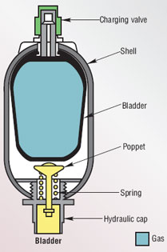
Fig. 5, Bladder type dampeners
However, bladder type dampeners have following disadvantages which ultimately affects the performance of the piping system.
- Doesn’t work if the process pressures are varying (i.e., Gas pre-charge is dependent on process pressure)
- Due to the line mounting design of damper and presence of throat, it is more effective at low frequency only and does not dampens high frequency pulsations.
- Frequent failures experienced when elastomeric material is not suitable for pump fluid
- Constant monitoring is required to ensure correct gas charge is available to effectively attenuate pulsation
- Contains moving parts such as bladder and poppet valves
- Many times, stocking of sufficient number of spare bladder is also not helpful, as ambient temperature has effect on the Rubber properties during warehouse storage.
Bladder-less type dampeners are available as alternative which works based on the low pass filter theory. There is no need for gas volume in this dampener and hence called as liquid filled dampener or all liquid dampener. Such type of dampers is designed with a choke tube and one or two volume.
Following are the key advantages of Bladderless design dampeners
- They can attenuate pulsation over a wide range of frequency from low too high.
- No moving parts, and are maintenance free.
- They are immune to changes in line pressure.

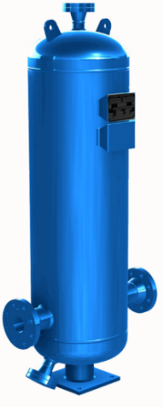
Fig. 6, Bladderless dampeners
Following are the dis-advantages of Bladderless design dampeners
- Bladder-less mechanical dampeners are usually large in size, roughly >100 times the volume of a gas filled dampeners.
- Require dedicated floor space and foundation due to its size and weight.
- Often Custom designed for the application, hence relatively expensive and longer lead time.
Selection of appropriate type of dampener during early phase of the project will result in trouble free start-up and operation and can avoid costly rectification of installed equipment and piping after initial start-up. For critical and high power applications, bladderless dampener at the pump discharge is suggested to attenuate the pulsation effectively and thereby protecting the downstream piping and equipment. Correct sizing of a pulsation dampener is critical to achieve the desired pressure pulsation of ±2% as per API 674. Off-the-shelf gas filled dampeners are always first choice for designers and careful evaluation to be made and compared techno-commercially with a bladderless dampener in applications where the temperature and the contaminants in the glycol are not favorable for elastomeric materials.
Selection of Design Approaches:
Reciprocating pumps generate dynamic pressure pulsations that interact with the piping system to create acoustical resonances and high pressure pulsations cause various problems which includes:
- Excessive piping vibration leading to piping and structural failures
- Opening of discharge relief valve leading to insufficient forward flow to downstream system and damage to the relief valve
- Cavitation in the suction side of pump
It is desirable to predict pressure pulsations at the design stage of an installation such that appropriate steps may be taken to minimize their levels and their influence. Dehydration Package designers always try to maintain their system layouts identical to their tried and tested layouts supplied in past, however the layouts are always not 100% identical and there is fair chance of performance variation from installation to installation.
Design Approach 1
- Acoustic review of selected equipment using empirical design methods
- Basic Review of pipe support spacing and layout to control natural frequencies
This approach includes the study, good piping layout, good support/restraint principles, and adequate NPIP to design a solution for limiting the pulsation levels to the API 674 allowable peak-to-peak pulsation level of each individual pulsation frequency component.

Design Approach 2
- Acoustical Simulation Techniques of pump, pulsation control equipment, and pipe network
- Mechanical pipe natural frequency analysis
- Support recommendations to shift natural frequencies 20% above first harmonic
This approach involves pulsation control using pulsation control devices developed using computer based proven acoustical simulation methods in conjunction with mechanical analysis of pipe runs and support systems to achieve control of vibration response.

Thorough analysis of the piping system is essential to have a smoother commissioning of the pumping system. Based on the criticality of the pumping system, Designer shall select the best suitable Design Approach as per API-674. For critical applications, Design Approach -2 with Mechanical Piping Study is recommended.
Review of Piping System:
Glycol circulation pumps often operates at a temperature condition from 60 degC to 120 degC and pressure condition range of 40 bar to 90 bar depending on the design of dehydration package.
As detailed above, piping system for reciprocating pump shall always be analyzed for pulsation induced forces and the piping design is adjusted to avoid mechanical resonance. Piping support spans and the support stiffness shall be adjusted to maintain the mechanical natural frequency (MNF) of the piping system to be 20% higher than the pump operating frequency (PPF). Many glycol dehydration packagers consider their dehydration system design to be an established and proven design. It is to be kept in mind that the layouts are always not identical and thorough analysis of the piping system is essential to have a smoother commissioning of the pumping system. Based on the criticality of the pumping system, designer shall select the best suitable design approach as per API-674. For critical applications, Design approach -2 with mechanical piping study is recommended.
Piping Support Requirements:
Often reciprocating glycol pump piping systems are complex for the piping designers. In general, the thermal analysis of the piping system requires to have flexibility for thermal expansion and associated stresses, whereas the piping system requires stiff support to control vibrations.
Supports in the piping system must be sufficient in controlling the unbalanced forces which are usually in the order of 200–600 lbf peak-to-peak, when the pulsation dampeners are properly sized. Support must be adequately stiff in all three co-ordinates to resist the unbalanced forces. It is normal practice in piping design to consider friction between Pipe shoe and support structure as restraining force. Hence to expect the piping system to function as desired, the pipe shoes / bare pipe wall must maintain contact with the support structure at all conditions. Wherever pre-loaded contact with the pipe is required, suitable spring loaded support to minimize the risk of vibration must be employed.
As a good practice, periodic inspection of the supports shall be performed routinely to ensure that the supports maintain required contact/pre-loaded contact with the pipe to minimize the risk of vibration.

Small bore piping’s and Instruments which are cantilever from the main pipe are prone to get damaged due to vibration and fatigue. Small bore connections such are Instrument tapping, vent, drain valves, etc. shall be braced back to main pipe. It is very common for Pressure or Temperature Gauges gets shattered due to insufficient supporting and vibration. Extensions of the Instrument, vent, drain tapping’s shall be kept as small as possible.
Pressure transducer, drain piping and other small bore branches have an insignificant effect on acoustical characteristics and are normally not included in the piping acoustic model. However, these small bore branches on pump suction and discharge lines can experience high vibration due to inherent high frequency mechanical excitation which cannot be controlled. If the vibration is severe, failure of these branches are first symptom of pulsation problem. It is always recommended to perform a piping vibration survey upon initial start-up to evaluate vibration acceptability of the piping support system.
As describe in the abstract, in place of reciprocating pump, client / packager shall look for alternate type of pumps to avoid issues/disadvantages associated with reciprocating pump, like centrifugal pump, screw pumps etc. as process requirement met and suitable selection available from the rotary / centrifugal pump range in other words, reliable pump offers various benefits such as least production interruptions and failure of expensive equipment.
Proposed option
Authors have found out that, with improved design, many rotary and / or centrifugal pump are available for low flow high head duty, with proven model from supplier such type of pump may be used.
Where possible, centrifugal pumps may be looked to use for glycol recirculation application, as centrifugal pumps has widely accepted in the industry. While using centrifugal pumps mostly BB5 (due to high pressure and low flow application), pulsation issue associated with reciprocating pump is mitigated. Flow adjustment with bypass arrangement met the turndown on the main process.
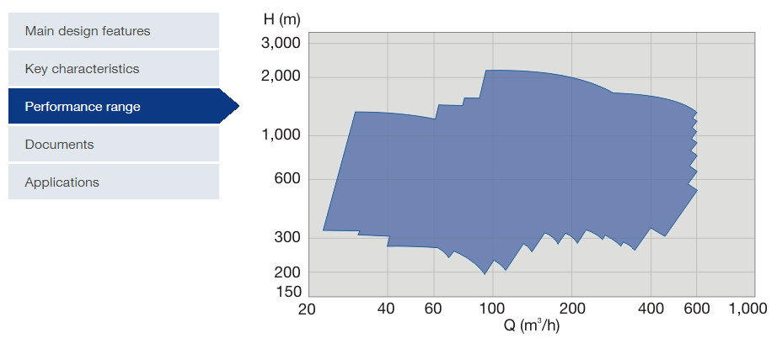
Figure 7. Selection range for low flow high head centrifugal barre type pump (Courtesy Sulzer).
Also, centrifugal pump with high pressure & low flow operating condition are now a days has well proven experience in

- No pulsating flow, low noise, well accepted across the industries
- Less wear and tear & hence low maintenance compares to reciprocating pump
- Smaller foot print compares to reciprocating pump
- Generally, centrifugal pumps have little less or equal overall efficiency as reciprocating pump means power consumption is equal or higher than reciprocating pump, however well designed and well selected centrifugal pumps can optimize the power consumption
- Normal maintained components are packing, seals for centrifugal pumps whereas for reciprocating many components are required for maintenance
- Flow rate can be changed with head without changing the speed of the centrifugal pump whereas flow rate can`t be changed without changing the speed of the reciprocating pump to meet the process requirement
Positive displacement pumps – such as piston, diaphragm, vane, gear and screw pumps – discharge discrete amounts of fluids into downstream piping. Each chamber (such as a piston or single vane) therefore creates a pressure rise and fall in the system piping. When plotted on a flow vs. time chart, these pressure changes form a sine wave, as shown in below figure (upper part).
This sine wave represents the instantaneous flow rate of a single chambered or simplex pump. The mean flow rate of this pump is the average discharge per revolution and is also the flow rating of the pump.
The increasing number of chambers will produce a decreasing amplitude of pressure pulsation. Theoretically, an infinite number of chambers will eliminate discharge pulsation. Practically speaking, the number of chambers varies by the type of pump construction. We commonly deal with piston pumps between one and eleven pistons, diaphragm pumps with one to four chambers, vane pumps with approximately 11 vanes, and gear pumps having even more chambers.
Since the severity of the amplitude decreases as the frequency increases, it can be well concluded that positive displacement pump such as screw pump shall generate very less amount of pulsation amplitude in system.

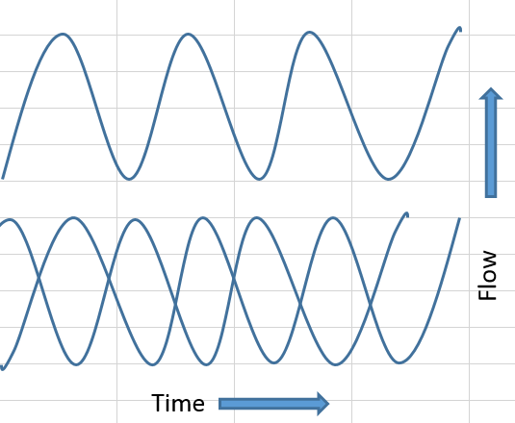
Fig.8 Pulsation comparison between Positive displacement (Reciprocating pump Vs Screw pump)
Double screw or multiple screw pumps compliant to API 676 are available till 100 bar pressure with up to 200 M3/hr flow rate.
- Hydraulically balanced, non-pulsating flow or very low pulsating flow thus low noise, without the need for pulsation dampeners, which eliminate stresses imposed on the pipeline system reducing the risk of pipeline failures.
- Only rotors are rotating parts (less rotating parts compare to reciprocating pump).
- Low noise and vibration levels, minimizing foundation requirements.
- Low total cost of owning and operating.
- Only one mechanical seal for driver rotor and is operating at suction pressure

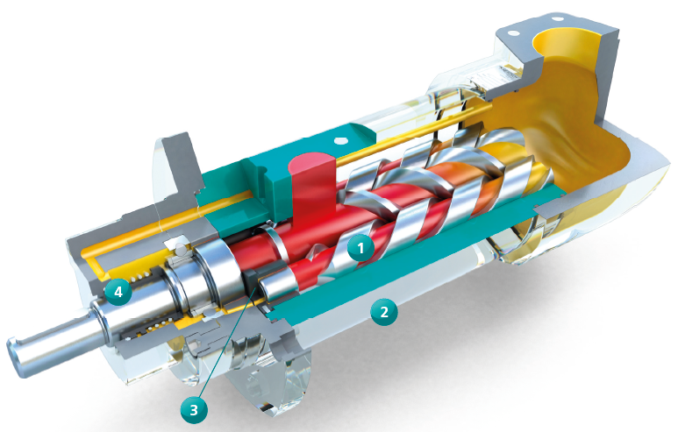

Figure 9. Cross section of twin screw pump.

The pump has two rotors, one drive and one driven, and relies on the pumped fluid to fill the clearances between the rotors and rotors and liner.

Theoretically screw pumps are vibration free so pulsation pressure is zero since we have the same volumetric flow per angle of rotation, however in practice this is found not to be the case. Most screw pumps exhibit 1-3% pressure differential.
The two mechanical factors contributing to pulsation are the compressibility of the fluid and the changes in sealing efficiency between the driven and suction chambers.
First calculate compressibility:
[Delta V = V*(compressibility factor) *P],
the compressibility factor is different for various fluids. Lower compressibility yields less shock absorption thus more vibration.
Most familiar are double-flow, self-priming, rotating positive-displacement twin-screw pumps, having totally four spindle profiles. These pumps are axially and radially fully balanced to avoid the need of special thrust bearings and to guarantee for long service life. The flow is split when entering the pump casing and transferred to each side of the double flow spindle package where it is pressurized to the common discharge. The rotors should be manufactured from one single piece of material which eliminates the risk of contact between the rotors and casing. This feature increases the structural integrity and service life of the spindles resulting in a greater operational reliability.

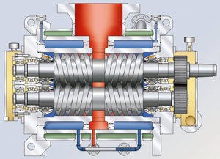

Figure 10. Cross section of twin screw with two stage.

If necessary a special modification can be done to the spindle profile, which leads to lower pump noise. The drive spindle torque is transferred to the driven spindle via oil-lubricated timing gears. This ensures an operation of the pump without any contact between the spindles and the replaceable casing insert and the spindle profiles themselves. An important feature of this type of pump is its ability to pump fluids in the viscosity range from 0.4 cSt to over 10,000 cSt. Furthermore, flow rates of up to 5,000 m³/h can be transported with just one pump. This type of positive-displacement pump also allows for dry running with fluids having low vapor pressure and when emptying tanks or pipelines.
When considering the aspects of maintenance and service, the single-flow pumps are very cost efficient and stand out positively. The following bullet points really hold true for these pumps:
- Fewer spare parts: An innovative and parts-saving pump design guarantees simplified stocking of spare parts by the operator or service contractor. The operator can thus calculate the benefits of an optimal stock keeping of parts with a lower service budget and capital tie-up.
- Simplified service and faster overhaul: This means in the field service! In most cases, service work can be carried out with less work and with smaller and lighter components directly on site, without the pumps having to be brought to an external shop.
- Less downtime for servicing (longer running times): Only pumps that are in operation contribute to the operating company’s profit. Thus, less downtime during servicing have a direct impact on the Company‘s financial result. Completely preassembled and tested cartridge units are available to speed service work even more. The operator only has to change the cartridge or the Pump ‘s entire internals at the time of service. The cartridge is simply slid out of the pump casing. A new cartridge can then be slid back into the pump casing and the pump is ready for operation again. The pump does not have to be removed from its base for this work.

References:
[1] API 674 3rd edition, Dec.2010, Positive displacement Pumps - Reciprocating
[2] API 676 3rd edition, Nov. 2009, Positive displacement Pumps - Rotary
[3] Hand book of Natural gas transmission and processing by William Poe
[4] Various OEM brochures of screw pump and high pressure centrifugal pumps
[5] Literatures on hydraulics by Brendan Casey
[6] Screw Pumps of One, Two and Three Screw Design - Wegener, Joachim; Cozza, Walter E. (Turbomachinery Laboratories, Department of Mechanical Engineering, Texas A&M University, 1985
[7] Pulsation: Cause and Solution by John Felsenthal, Quality Hydraulics & Pneumatics

